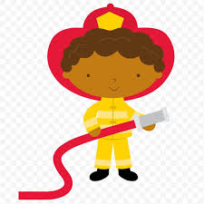
February 2020
Sunday | Monday | Tuesday | Wednesday | Thursday | Friday | Saturday
26  Hats & Mittens | 27 | 28 | 29 | 30 | 31 | 1
2  What is community? | 3 | 4 | 5  Chapel | 6 | 7 | 8
9  Mail Carriers | 10 | 11  Story Time with Ms. Londra | 12  Chapel  Happy Birthday Ms. Nicole! | 13 | 14 | 15
16  Firefighters & Police Officers | 17  School Closed  Staff Workday | 18 | 19  Chapel | 20 | 21  Happy Birthday Magnolia! | 22  Happy Birthday Mr. Ryan!  Casino Night Fundraiser
23  Doctors & Nurses | 24 | 25 | 26 Chapel | 27 | 28 | 29
Bible Verse: “A friend loves at all times.” Proverbs 17:7
Fruit of the spirit: Love

